The website which I have made is for customer orders. I am basically a business operating from home where I allow registered customer to place an order through the website and the order will be sent to me. I allow customers to purchase what is available on the menu and then they can come and pick it up the order from my home.
Below are the screenshots explaining everything:

1. This will be the register page where new customers can sign up.


2. This is the login page where customers can sign in. The demo username is “admin”. The demo password is “user”. The demo email address is “adminuser@gmail.com”.

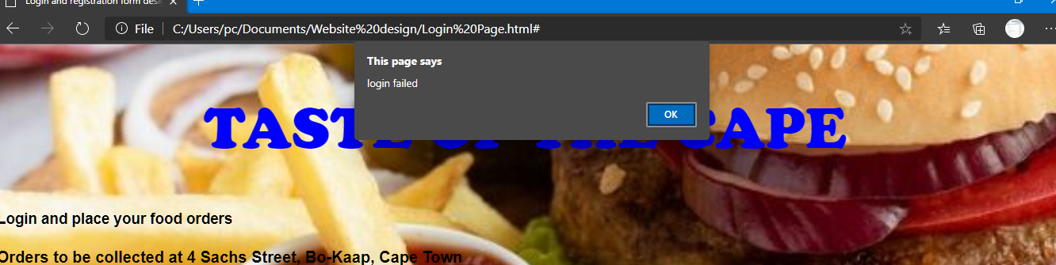
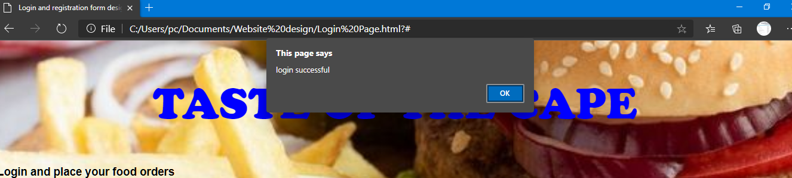
3. When the customer puts in the details and a message (“login failed” or “login successful”) will be displayed and this will inform the customer if the login details are correct or not.

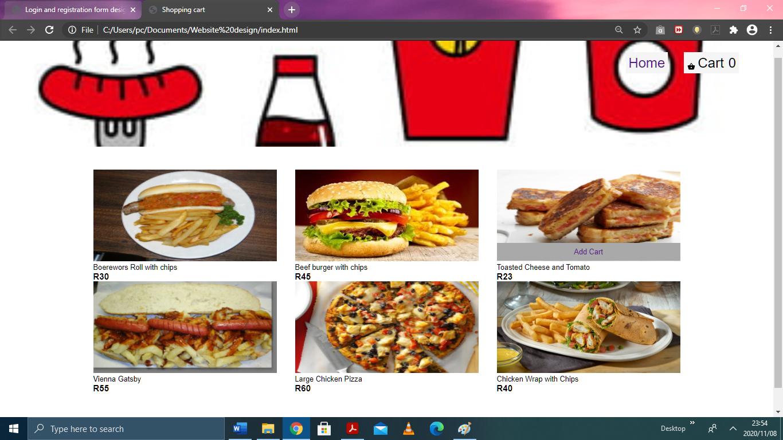
4. Once the login details are successful, the customer will be redirected to a second page where they will be able to look at the menu and they will be able to add the items to the cart and the cart in the top right-hand corner will display how many items are in the cart.

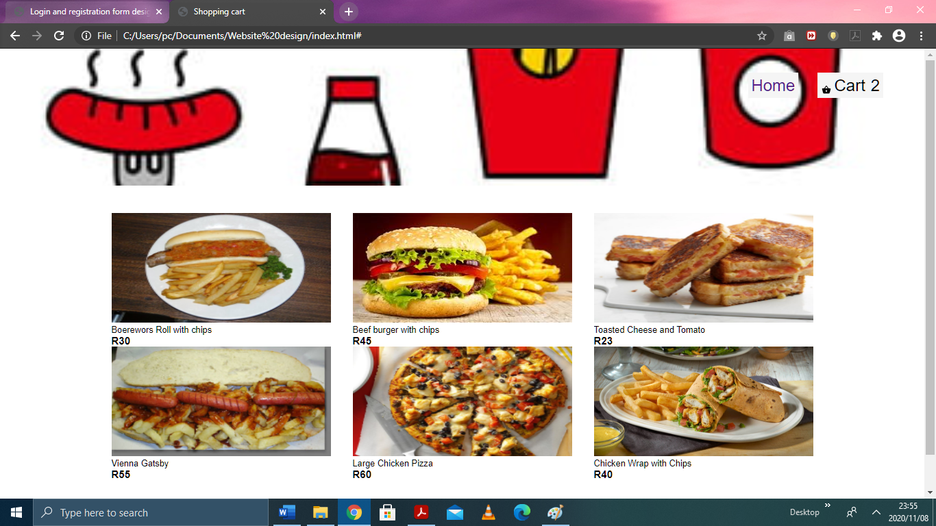
5. Once the customer has decided, they have to click on “cart” and this will direct them to a “checkout” page where they can see all the items which they have added to the cart.
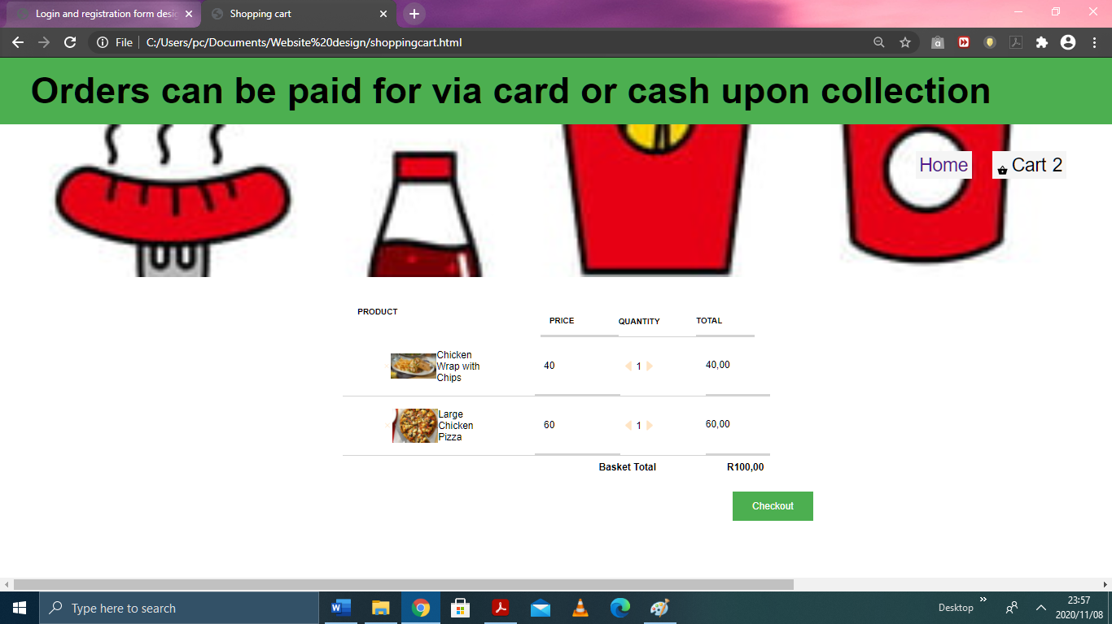

6. Once the customer had clicked “Checkout”, then an alert message will say that the order has been successfully processed.
